COP 2271 Assignment 3:

#include <stdio.h>

int main() {

printf("%+.5d\n", -123);

printf("%+.5d\n", 123);

printf(" 123\n");

printf("123 \n");

printf("%2.2e", 123.0);

return 0;

}

Problem 2:

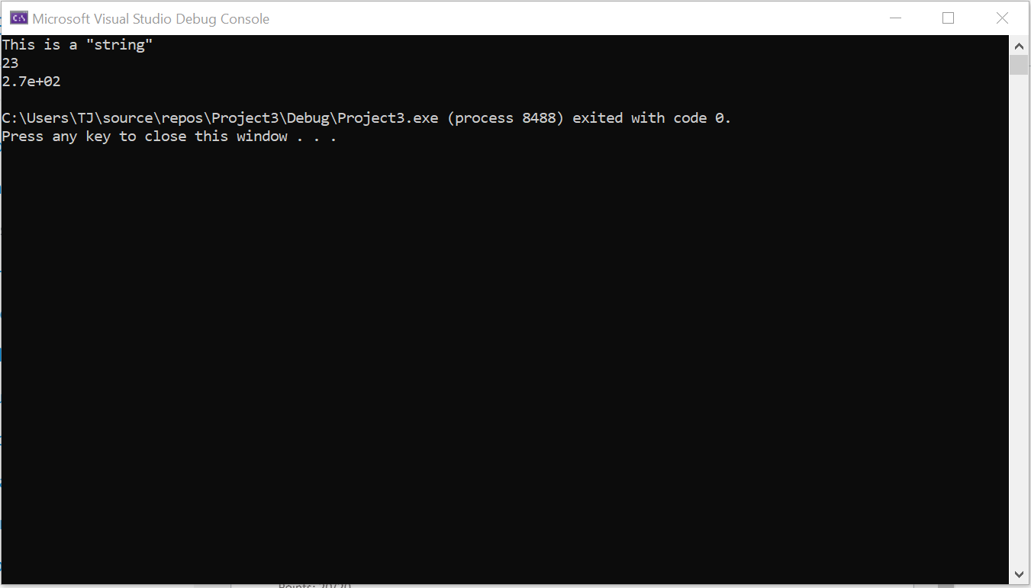

Problem 3:

1. Scanf requires the & identifier when calling a variable. The line should read (scanf_s(“%d”,&num);)
2. This has the same issue as number 1, along with this, it is using the wrong specifier for the float format. the line should read (scanf_s(“%f”,&f);
3. This uses the wrong specifier for the short format. The line should read (scanf_s(“%hi”, &sh);

Problem 4:

#include <stdio.h>

int main() {

int a, b;

char oper;

puts("Please enter the operation: ");

scanf_s("%c", &oper);

puts("Enter two integers: ");

scanf_s("%d%d", &a, &b);

//asks user for operator and two integers

if (oper == '+') {

printf("%d %c %d = %d", a, oper, b, a + b);

}

else if (oper == '-') {

printf("%d %c %d = %d", a, oper, b, a - b);

}

else if (oper == '*') {

printf("%d %c %d = %d", a, oper, b, a * b);

}

else {

printf("%d %c %d = %d", a, oper, b, a / b);

}

return 0;

}

